Music@FIRST!

After a few years’ hiatus, First Congregational United Church of Christ is once again offering a free concert to help kick off the North Iowa Band Festival Weekend in Mason City. Music@First! is excited to announce that Kevin “B.F.” Burt, a blues guitarist and singer from Iowa City, will be with us on Thursday, May 26th at 7:30 p.m. We are located at 100 First St. NE (on the corner of Delaware and First St. NE).

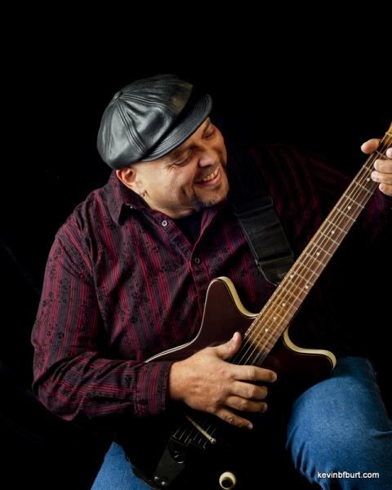
Iowa Public Radio Studio One's "Java Blend," host, Ben Kieffer introduced Kevin in 2014 saying: “For over 20 years, Kevin “B.F.” Burt has been electrifying audiences throughout the nation dispelling the myth that true blues has no roots in Iowa. His soul-inspired presentation is unique which consistently gets him compared to a range of artists like Bill Withers and Aaron Nevill, with the ability to build an audience rapport that has been compared to B.B. King.“ Playing with his band, The Blues Instigators, Kevin has opened for B.B. King; played at the original House of Blues in Boston, and Beale St. in Memphis; and at the Bitter End in New York.

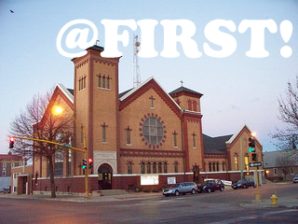
First Congregational UCC was the church home of Meredith Willson and celebrates with Mason City a long history of wonderful music. Join us for an evening of The Blues.

For more information:
Find us on Facebook “firstchurchmasoncity”
Contact Pastor Chuck Kelsey 641-530-0351

